# Co 2 klatki

# No ByteRun

subsampling = 4:4:4

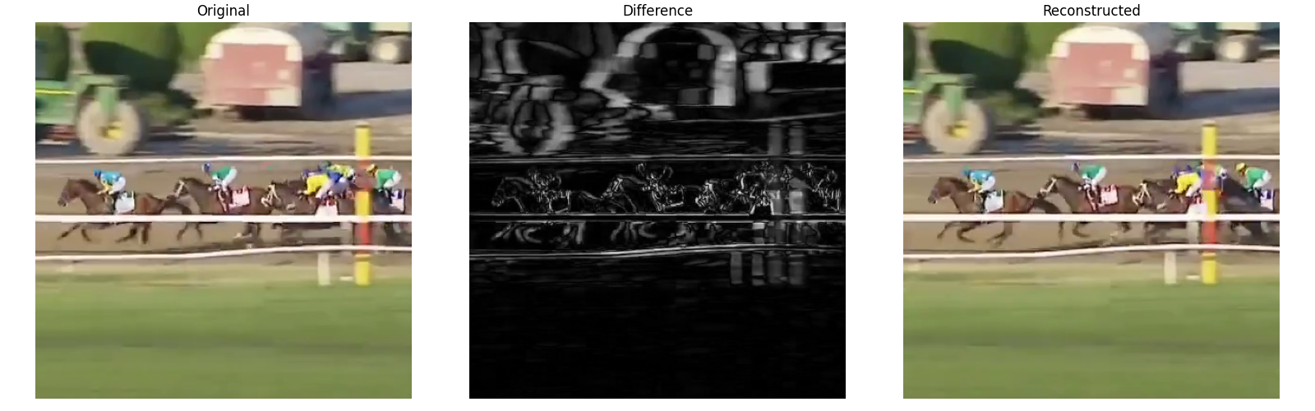

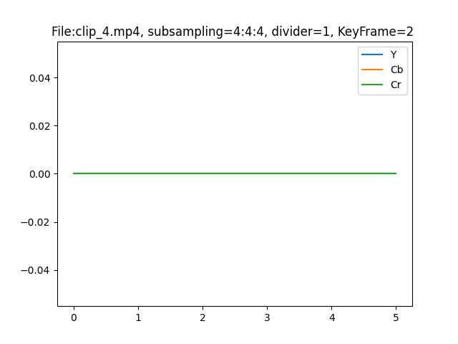

subsampling = 4:2:2

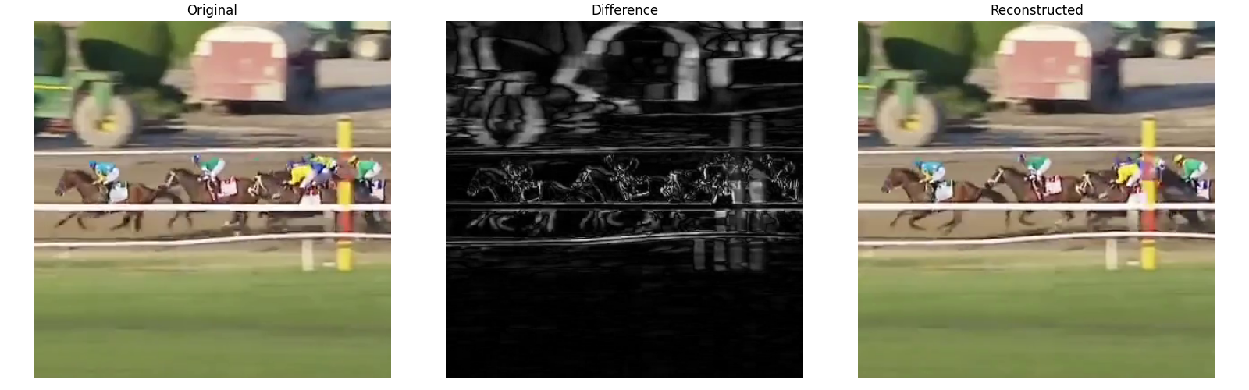

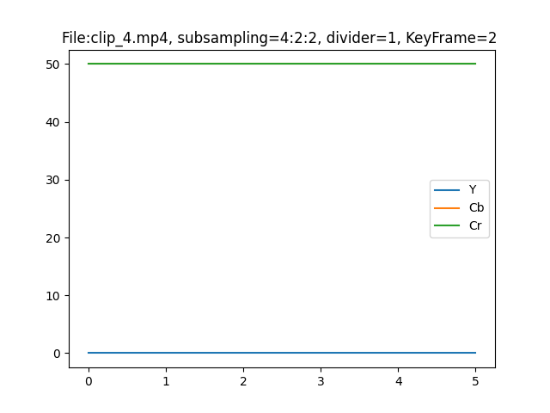

subsampling = 4:4:0

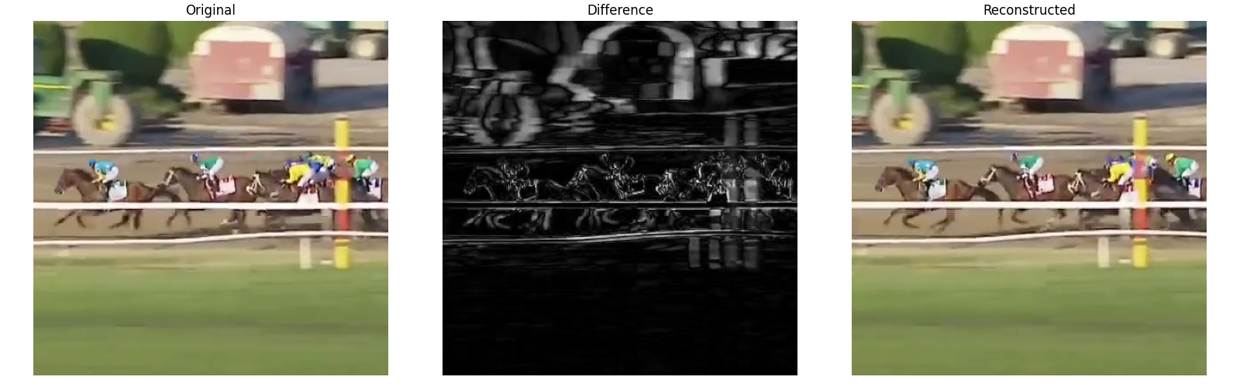

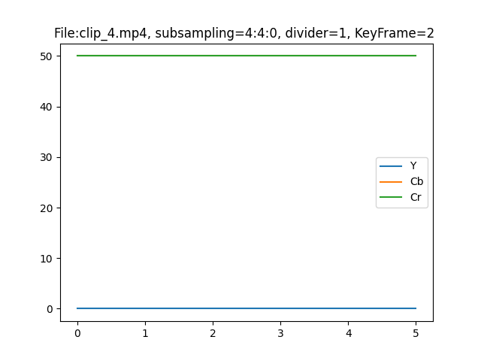

subsampling = 4:2:0

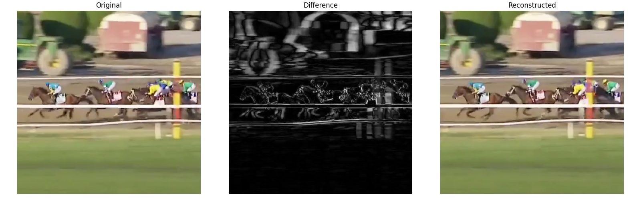

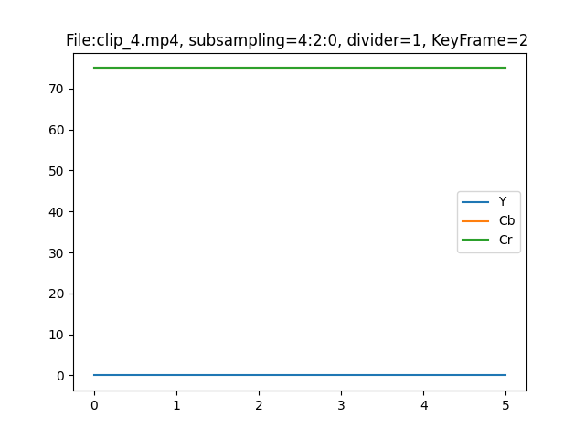

subsampling = 4:1:1

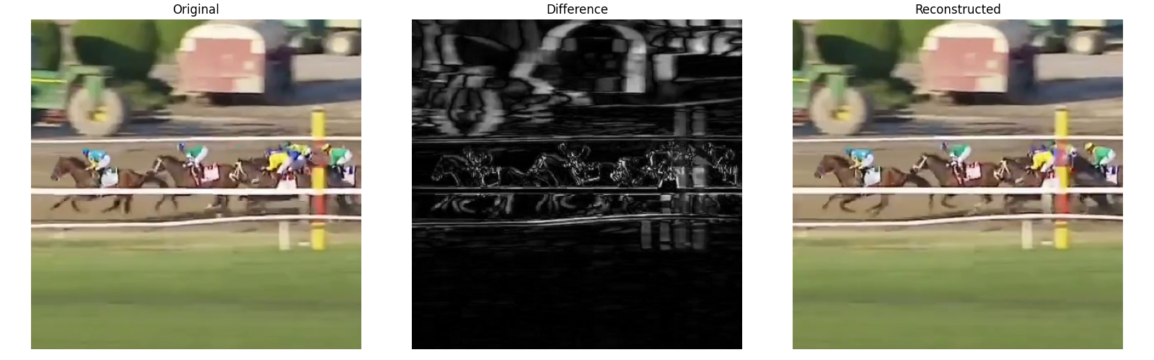

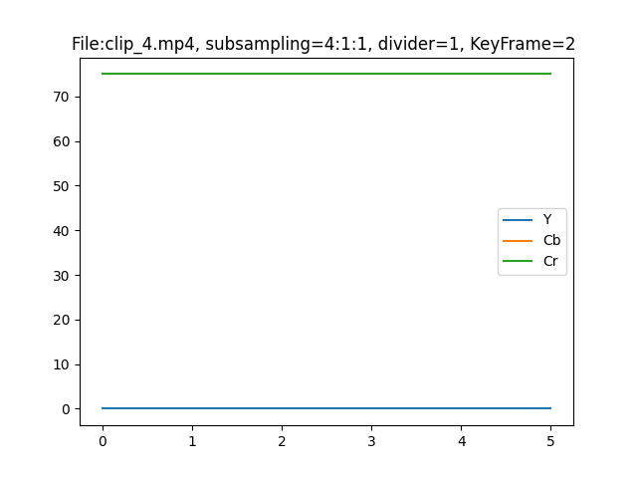

subsampling = 4:1:0

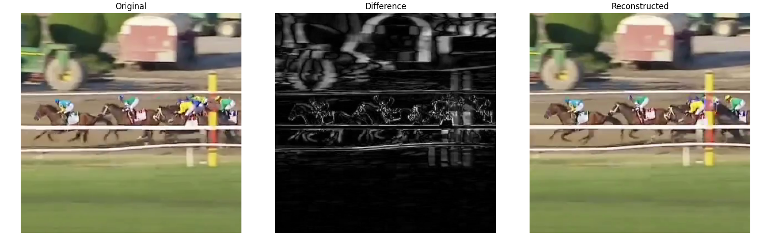

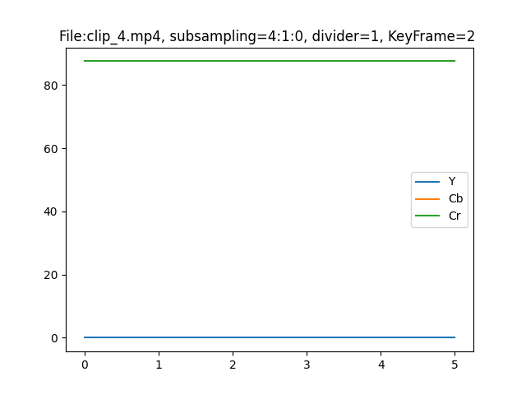

subsampling = 4:4:4

divisor = 2

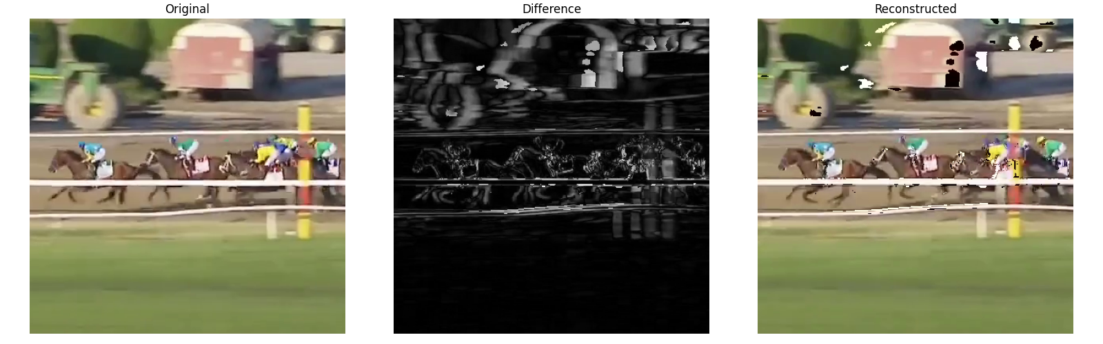

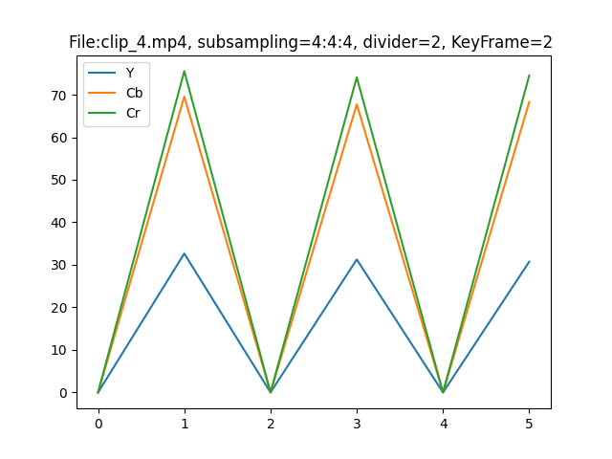

divisor = 4



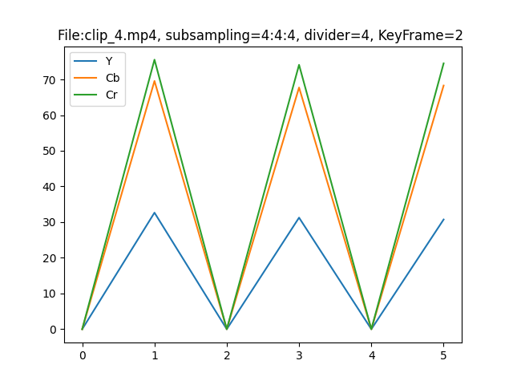

subsampling = 4:2:0

divisor = 2

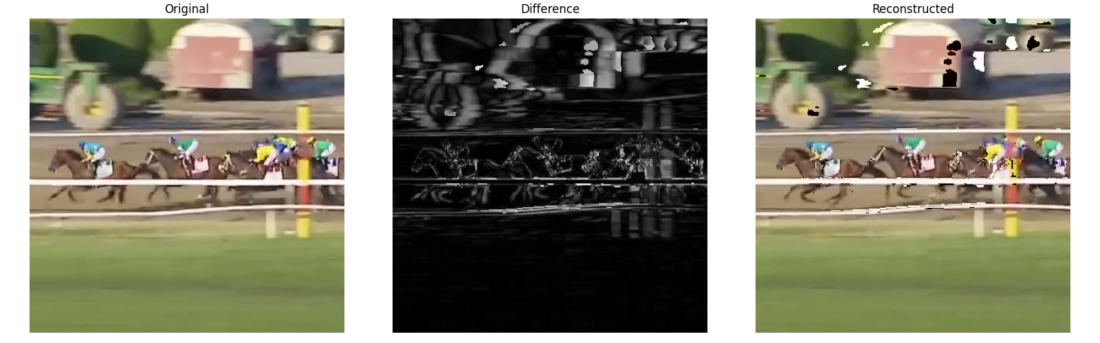

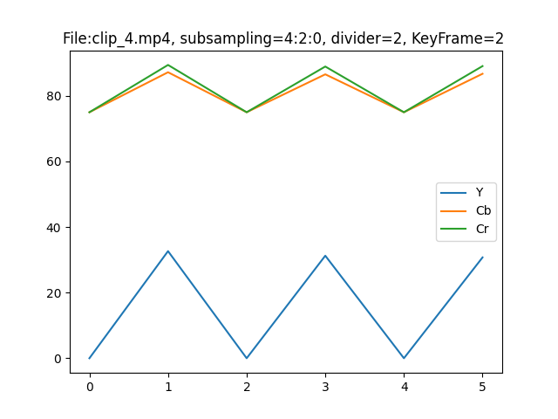

divisor = 4



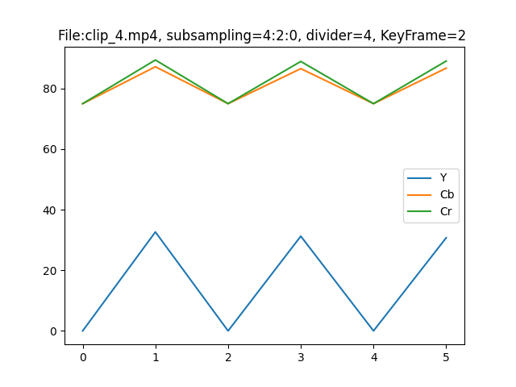

subsampling = 4:1:0

divisor = 2

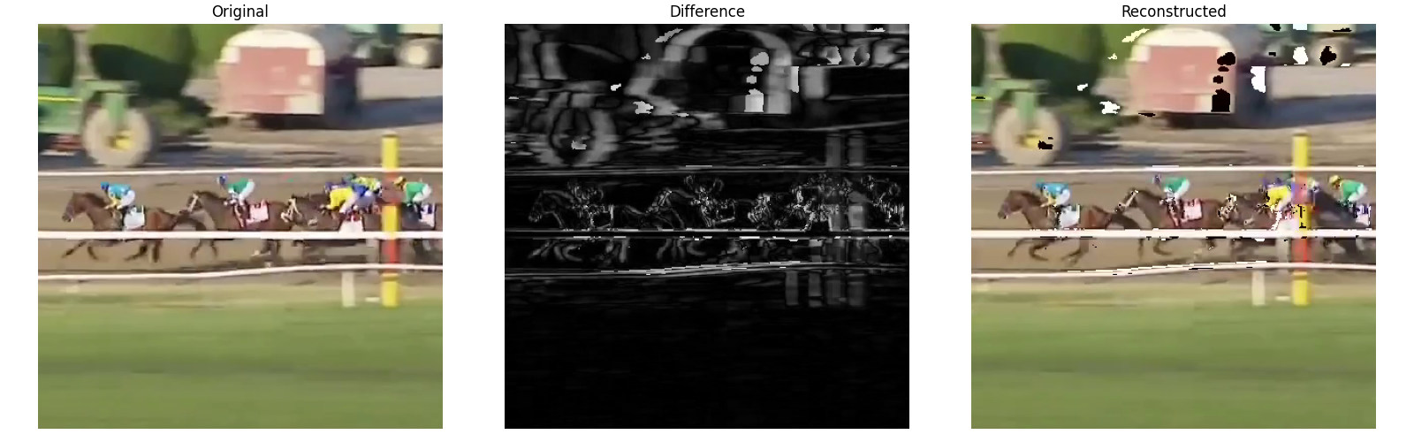

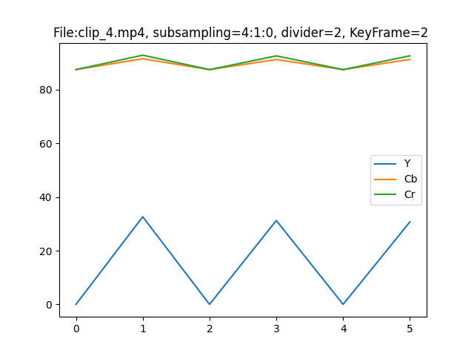

divisor = 4

